CAPSTONE PROJECT REPORT
Best Buy Automation | Selenium Testing Report

Name | Shaurya Singh
Superset ID | 4957864
Project Type | Capstone Project
Project Name | Best Buy Automation Testing using Selenium PyTest and Behave BDD Framework
Domain | E-Commerce
Module Title | Trending Deals

PROJECT DESCRIPTION
This project automates the Best Buy web application using Selenium WebDriver with Python. The automation framework covers the Trending Deals module on the Best Buy e-commerce platform, validating price filter functionality, product grid behaviour, and end-to-end cart workflow using both Selenium PyTest and Behave BDD frameworks.

The framework is designed using the Page Object Model (POM) architecture to improve maintainability and reusability. Screenshots, logs, Allure reports, and reusable utilities are integrated to support execution tracking and debugging. The project includes both positive and negative testing scenarios using industry-standard automation testing practices.

SELENIUM PYTEST FRAMEWORK

TEST STRATEGY
The Selenium PyTest framework automates the Best Buy Trending Deals module using Selenium WebDriver with Python PyTest. The framework validates price filter functionality including invalid range detection, zero range product grid behaviour, and positive price range validation. It supports End-to-End, Positive, Negative, and Data-Driven testing using JSON-based and CSV-based test data. Allure Reports are integrated for professional execution reporting with screenshot evidence and detailed execution logs.

Tools Used:
- Selenium WebDriver
- PyTest
- Allure Reports
- Python Logging Module
- Screenshot utility

TEST ENVIRONMENT
Operating System | Windows 11
IDE | PyCharm
Browser | Google Chrome
Framework | Selenium + PyTest
Design Pattern | Page Object Model (POM)
Reporting Tool | Allure Reports
Language | Python 3.12.2

FRAMEWORK ARCHITECTURE
TrendingDeals/
├── data/
│ ├── categories.json
│ └── price_range.csv
│
├── locators/
│ ├── home_locator.py
│ ├── base_locator.py
│ ├── category_locator.py
│ └── cart_locator.py
│
├── pages/
│ ├── home_page.py
│ ├── base_page.py
│ ├── category_page.py
│ └── cart_page.py
│
├── tests/
│ ├── test_home_page.py
│ ├── test_base_page.py
│ ├── test_category_page.py
│ └── test_end_to_end.py
│
├── utils/
│
├── screenshots/
│
├── reports/
│ ├── screenshots/
│ ├── results_category/
│ └── allure_report_category/
│
├── logs/
│
├── conftest.py
└── requirements.txt

TEST EXECUTION
The automation suite includes 1 End-to-End test case, 4 Positive test cases, and 3 Negative test cases.

End-to-End Test
The End-to-End test validates the complete Best Buy Trending Deals workflow. Starting from the Laptops and Computers category page, the test applies a price filter between $500 and $2000, verifies that products are visible and the first product price falls within the specified range, adds the first product to the cart by clicking the Add to Cart button, navigates to the cart page via the cart icon, and confirms that the cart page loads successfully with the correct URL. This test validates the entire purchase flow from product discovery through cart confirmation.

Positive and Negative Tests
The category page test starts by reading a category dynamically from categories.json and navigating to it from the Trending Deals page. The correct category page is verified using the expected URL format. Multiple price filter scenarios are then tested on the category page. In invalid cases like 500–100 and 100–0, validation alerts are triggered and verified, ensuring improper ranges are rejected. For the edge case 0–0, no products are displayed, confirming correct handling of zero results. In valid cases such as 0–100 and 100–1000, products are displayed successfully and filters are applied correctly. Finally, in the 100–500 case, a product is added to the cart and the cart page is verified, completing the end-to-end flow.

SELENIUM TEST CASE SUMMARY
S.No | Test Type | Test Scenario | Expected Result | Status
1 | Positive and End-to-End | Complete Price Filter and Add to Cart Workflow for Price Range Validation (500 to 2000) | User successfully lands on cart page with product added | Passed
2 | Positive | Clicking on Category taken from a json file | User successfully lands on category page | Passed
3 | Positive | Price Range Validation (100 to 1000) | Products visible and first product price within range | Passed
4 | Negative | Invalid Range Alert (500, 100) | Alert displayed with invalid range message | Passed
5 | Negative | Invalid Range Alert (100, 0) | Alert displayed with invalid range message | Passed
6 | Negative | Zero Range Grid Vanishes (0, 0) | Product grid disappears after filter applied | Passed
7 | Positive | Zero Range Grid Vanishes (0, 100) | Product still displayed | Passed

OUTPUTS

The framework automatically captures screenshots during important execution stages.

Detailed execution logs are generated using Python logging framework for debugging and execution tracking

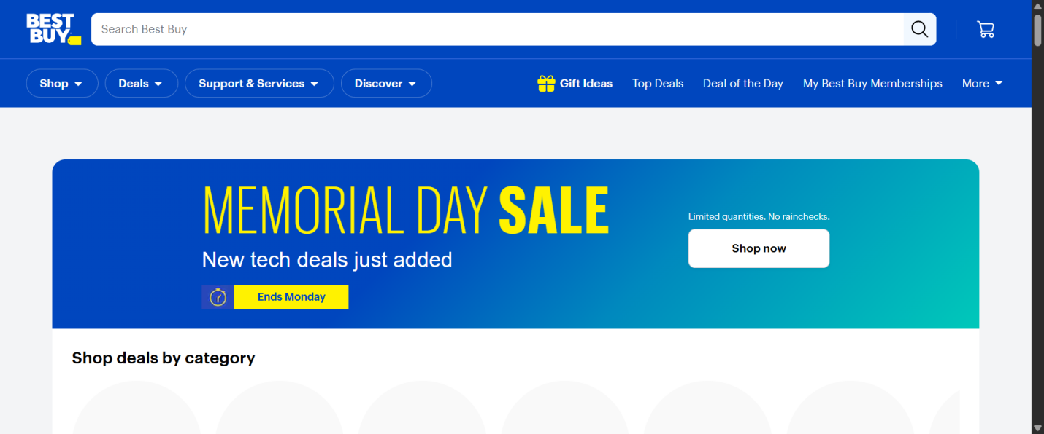
Fig-1 Website Opening

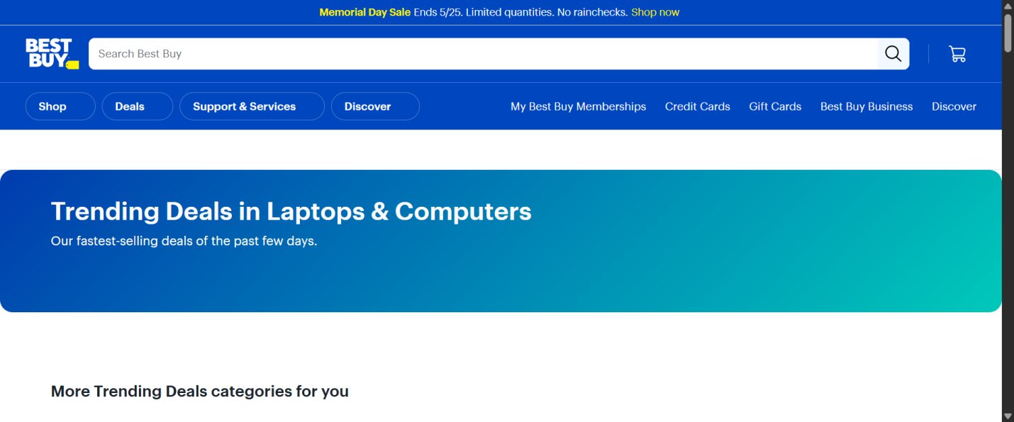
Fig-2 Trending Deals Page

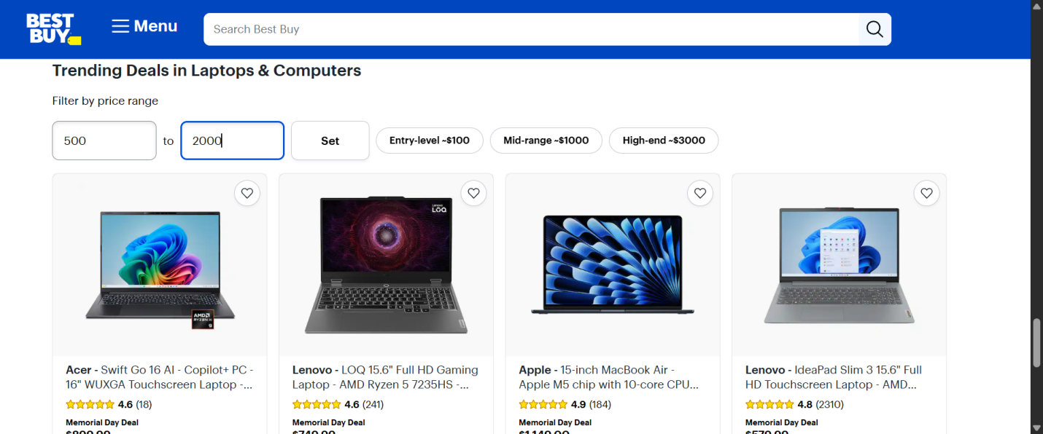
Fig-3 Price Range Filter applied

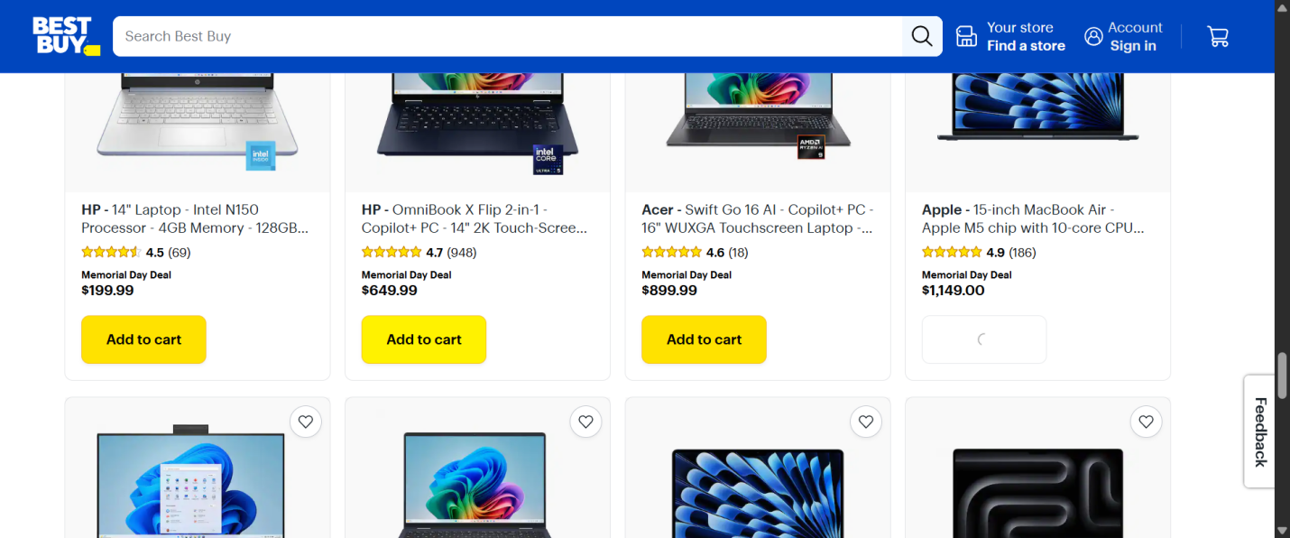
Fig-4 Adding product to cart

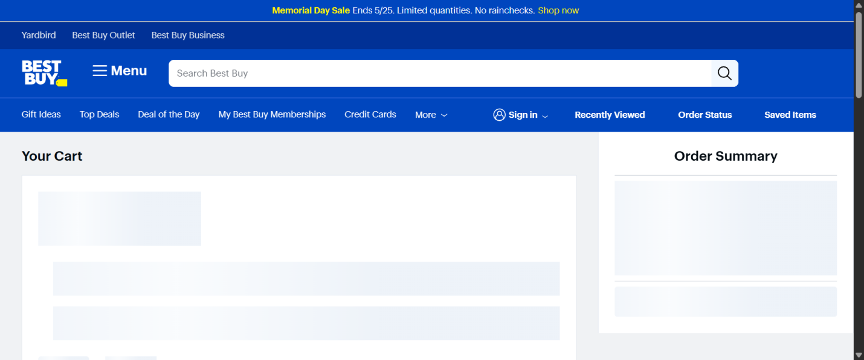
Fig-6 Cart Page

Allure Report
Allure Reports are integrated with the Selenium PyTest framework to generate professional execution reports for the Best Buy Trending Deals automation suite. The reports display passed status, capture screenshots at key execution stages including category page load, price filter application, alert detection, price range validation, and cart page load. Per-test logs are attached to each test entry for debugging and tracking, and the reports provide a detailed execution summary with total tests executed, pass and fail counts, and step-by-step execution flow.

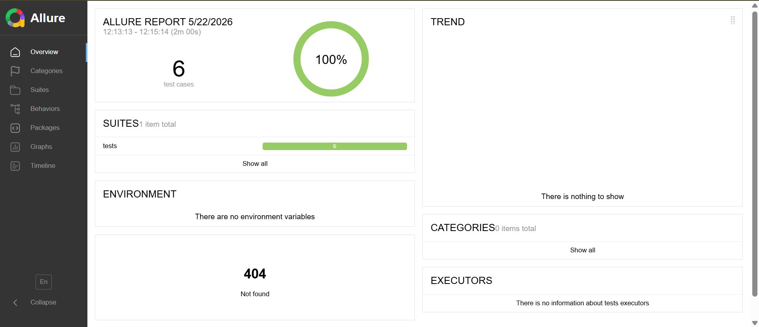
Fig-7 Allure Report

TEST REPORT
Total Tests Executed: 7
Tests Passed: 7
Tests Failed: 0
Automation Accuracy: 100%

CONCLUSION
The Selenium PyTest automation framework successfully validates the Best Buy Trending Deals module using End-to-End, Positive and Negative testing approaches. The framework is designed using Selenium WebDriver, PyTest Framework, Page Object Model, Allure Reporting, Logging Framework, and Data-Driven Testing with CSV. The automation improves test maintainability, reusability, scalability, reporting quality, and automation reliability. All test cases executed successfully with professional reporting, screenshot capture, and detailed execution logs.

SELENIUM BDD FRAMEWORK

TEST STRATEGY
The Selenium Behave BDD framework automates the same Best Buy Trending Deals module using Behavior Driven Development methodology. Test scenarios are written in Gherkin syntax using Given-When-Then structure, making them readable by both technical and non-technical stakeholders. The framework validates the same price filter scenarios as the PyTest suite but expressed as business-readable feature files. Scenario Outlines with Examples tables are used for data-driven testing, providing the same parametrization capability as PyTest marks. Allure Reports are integrated with the Behave formatter to generate professional execution reports with per-scenario screenshot evidence and isolated log attachments.

Tools Used:
- Selenium WebDriver
- Behave BDD Framework
- Allure Reports (allure-behave)
- Logging Module

TEST ENVIRONMENT
Operating System | Windows 11
IDE | PyCharm / VS
Browser | Google Chrome
Framework | Selenium + Behave BDD
Design Pattern | Page Object Model (POM)
Reporting Tool | Allure Reports
Test Approach | Behavior Driven Development (BDD)
Language | Python 3.12.2

FRAMEWORK ARCHITECTURE
TrendingDealsBDD/
│
├── data/
│ └── price_range.csv
│
├── features/
│ ├── 01_price_filter.feature
│ ├── 02_end_to_end.feature
│ ├── environment.py
│ └── steps/
│ └── trending_deal_steps.py
│
├── locators/
│ ├── base_locator.py
│ ├── category_locator.py
│ └── home_locator.py
│
├── logs/
│ └── automation.log
│
├── pages/
│ ├── base_page.py
│ ├── category_page.py
│ └── home_page.py
│
├── utils/
│ ├── csv_reader.py
│ ├── driver.py
│ ├── logger.py
│ └── screenshot_util.py
│
├── allure-results/
├── allure-report/
├── conftest.py
└── requirements.txt

TEST EXECUTION
The automation suite includes 1 End-to-End test scenario, 2 Positive test scenarios, and 4 Negative test scenarios (reduced due to the change in the website on for 0-100 price range filter).

End-to-End Scenario
The End-to-End scenario validates the complete Best Buy Trending Deals cart workflow using BDD methodology. The Background step navigates from best buy website to the Laptops and Computers category page. The scenario then enters a price filter range of $500 to $2000, clicks the Set button, verifies that products are visible on the page, confirms the first product price falls within the specified range using a soft assertion that logs warnings without failing the test, adds the first product to the cart, clicks the cart icon to navigate to the cart page, and asserts that the cart page loads successfully. Any chromedriver timeout exceptions during the cart icon click are caught, logged as expected behaviour, and the scenario is marked as passed with the exception documented in the Allure report.

Positive and Negative

The automation framework validates the Best Buy Trending Deals price filter functionality through a comprehensive set of positive and negative test cases. The two negative invalid range test cases (500, 100) and (100, 0) verify that the application correctly raises a browser alert with the message "Minimum value cannot be greater than the maximum value." when the minimum price exceeds the maximum, ensuring proper input validation on the price filter. The two negative zero range test cases (0, 0) and (0, 100) validate that entering zero-based price ranges causes the product grid to disappear from the DOM, confirming that the filter correctly removes all products when no valid price range is specified, with soft assertions used to handle any site response timing variations. The positive test case with a range of 100 to 1000 confirms that applying a valid price filter displays products on the page and that the first product price falls within the specified range, validating the core filtering functionality of the category page. Together these five test cases provide complete coverage of the price filter feature across valid, invalid, and boundary input conditions, ensuring the filter behaves correctly for both expected and unexpected user inputs.

BDD IMPLEMENTATION
The framework follows Behavior Driven Development using Feature Files, Step Definition Files, Gherkin Syntax, and Given-When-Then structure. Background steps initialise the page objects before each scenario. Scenario Outlines with Examples tables drive the parametrized negative test cases. Soft assertions are used for zero range and price validation scenarios to allow the test run to continue while logging failures.

SELENIUM TEST CASE SUMMARY
S.No | Test Type | Test Scenario | Expected Result | Status
1 | End-to-End and Positive | Filter, Add to Cart and Verify Cart (500-2000) | Cart page loads with product added successfully | Passed
2 | Positive | Price Range Validation (100 to 1000) | Products visible and first product price within range | Passed
3 | Negative | Invalid Range Alert (500, 100) | Alert displayed with invalid range message | Passed
4 | Negative | Invalid Range Alert (100, 0) | Alert displayed with invalid range message | Passed
5 | Negative | Zero Range Grid Vanishes (0, 0) | Product grid disappears after filter applied | Passed
6 | Negative | Zero Range Grid Vanishes (0, 100) | Product grid disappears after filter applied | Passed

OUTPUTS

The framework automatically captures screenshots during important execution stages.

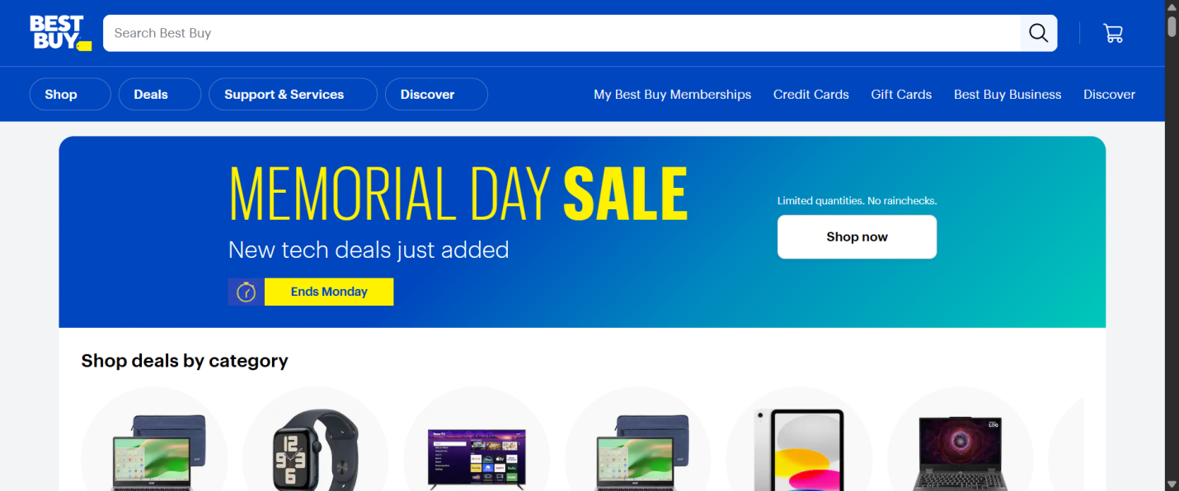
Fig-8 Home page

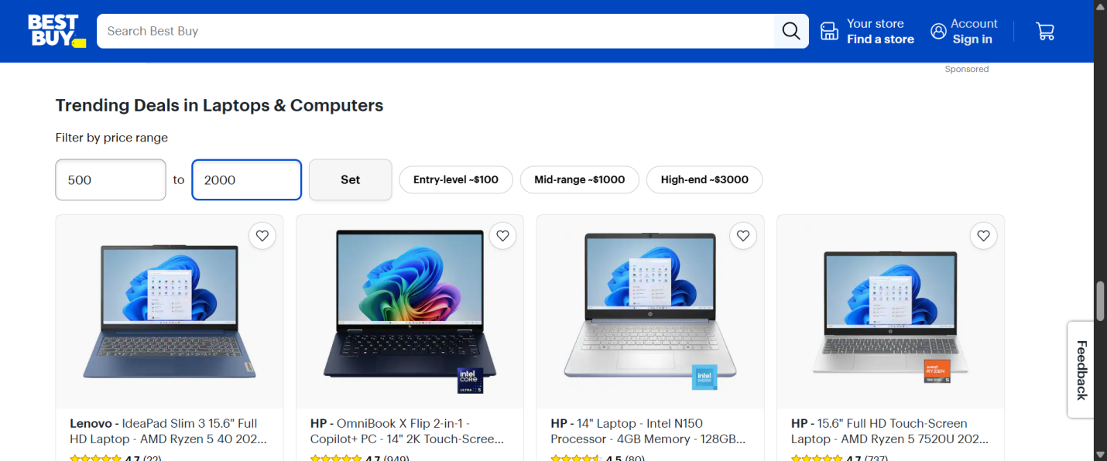
Fig-9 Price Range Filter applied

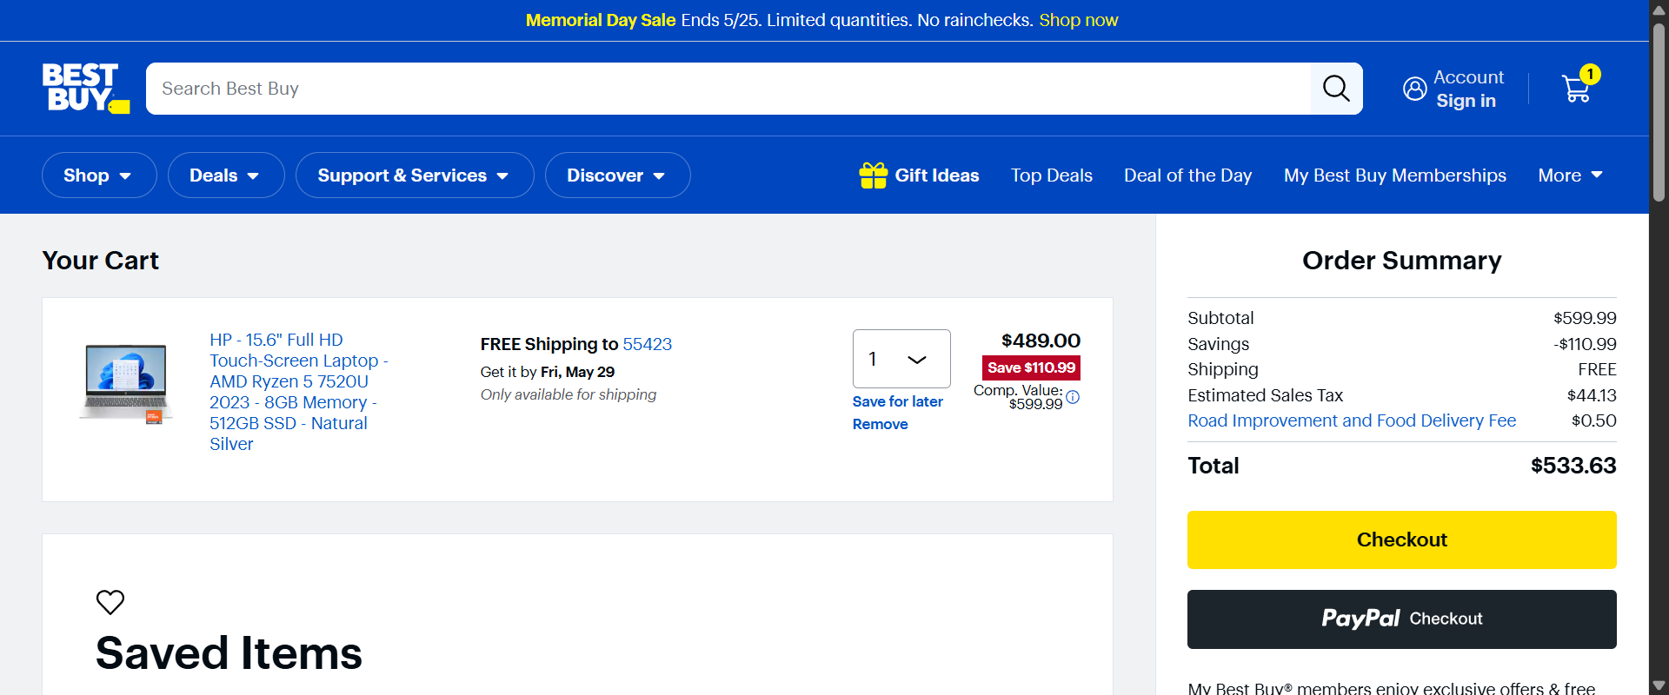
Fig-10 Cart Page

Detailed execution logs are generated using Python logging framework for debugging and execution tracking

ALLURE REPORTS
Allure Reports are integrated with both the PyTest and Behave BDD frameworks to generate professional execution reports. The reports display passed and failed scenario status, capture screenshots during execution at key steps including category page load, filter application, alert detection, price validation, and cart page load. Per-scenario logs are attached to each test in the report for debugging and tracking. The reports maintain execution history, display step-by-step execution flow, and provide a detailed execution summary.
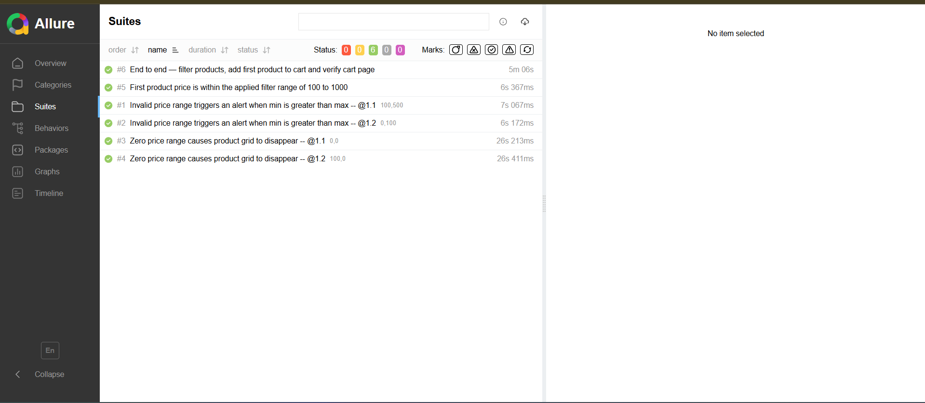
Fig-11 Allure Report

TEST REPORT
Total Scenarios Executed: 6
Scenarios Passed: 6
Scenarios Failed: 0
Automation Accuracy: 100%

CONCLUSION
The Selenium Behave BDD automation framework successfully validates the Best Buy Trending Deals module using Behavior Driven Development methodology. The framework is implemented using Selenium WebDriver, Behave BDD Framework, Gherkin Feature Files, Step Definition Files, Page Object Model, Allure Reporting, and Data-Driven Testing. The implementation of Feature Files and Given-When-Then structure improves readability, maintainability, and collaboration between technical and non-technical stakeholders. The framework also includes Professional Allure Reports, Screenshot Evidence, Detailed Execution Logs, Positive and Negative Testing, and Reusable Automation Components. All scenarios executed successfully with accurate validations and detailed reporting. Overall, the project demonstrates a professional real-world BDD automation framework with scalable architecture, reusable components, and reliable automated testing practices.

